Starting with deliverables of the BI final project, we had to do various analysis across widely different sets of data. Deliverables included Contributions analysis, Ranked(Topx) analysis, Period over Period and Trends analysis, Promotion analysis with margin and impact of sales etc.

From our understanding from the reading book for DWBI, we have decided that for Contribution analysis it is always good to use Heat maps. It can accommodate a large number of slices, especially when we use a color gradient to enhance its usefulness. The best visualization for time series, period by period is the line charts and bar charts. We used bar charts for period over period and line charts with forecasting for line charts

For comparative we generally use a bar chart which shows a clear comparison analysis. We have created a measure for margin while doing the promotion analysis. Geography analysis is always preferable to use a map analysis.

While working on the four tools, these are the differences we have encountered,

* When we create a Hierarchy in tableau, it wont be seen any more under that dimension it belongs to. To access that again we have to search in the hierarchy and use it. But in PowerBI even if we create a hierarchy, a duplicate value still remains at it original dimension, which is easy to reuse, saves time from searching for the hierarchy.
* PowerBI has black background UI on the right hand side of the working screen where we add fliters and legends, it becomes a little difficult at time to find the field or filter you are looking for. Where as in Tableau, it is very bright and everything is easy to find and filter.
* Tableau by far has been the most user friendly tool for us, all the analysis and jobs were done without any problem, where as coming to Qlik and PowerBI, they are a little complicated to use than tableau.
* While forecasting in tableau, it can forecast data even for multiple analysis lines in a line chart, where as PowerBI doesn’t do a forecasting if more than one line is on the line chart.
* 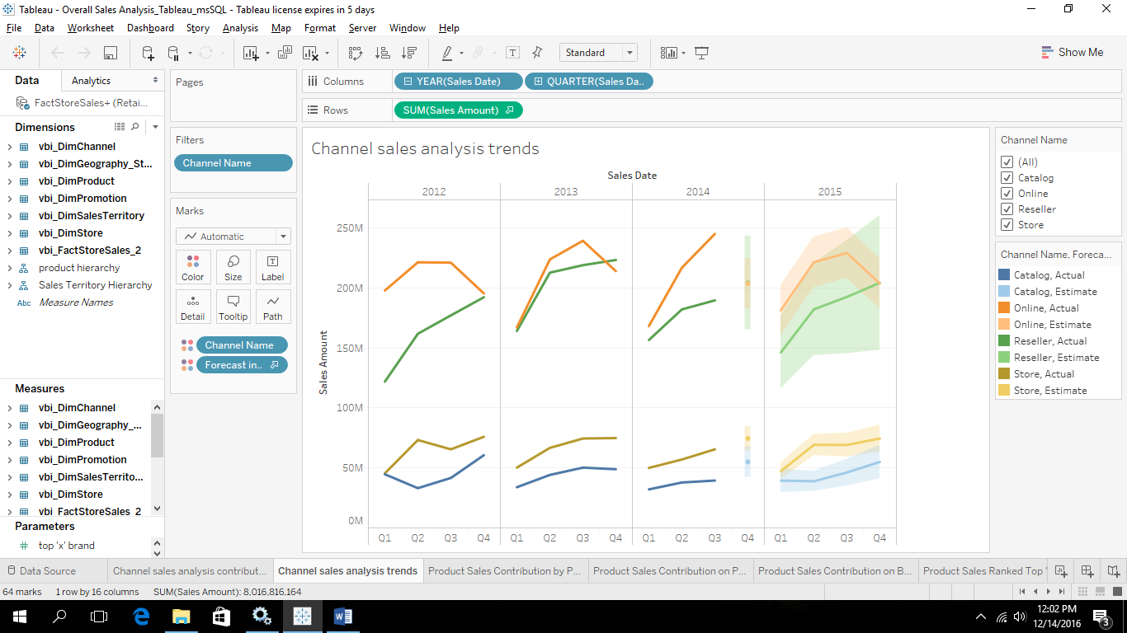
* 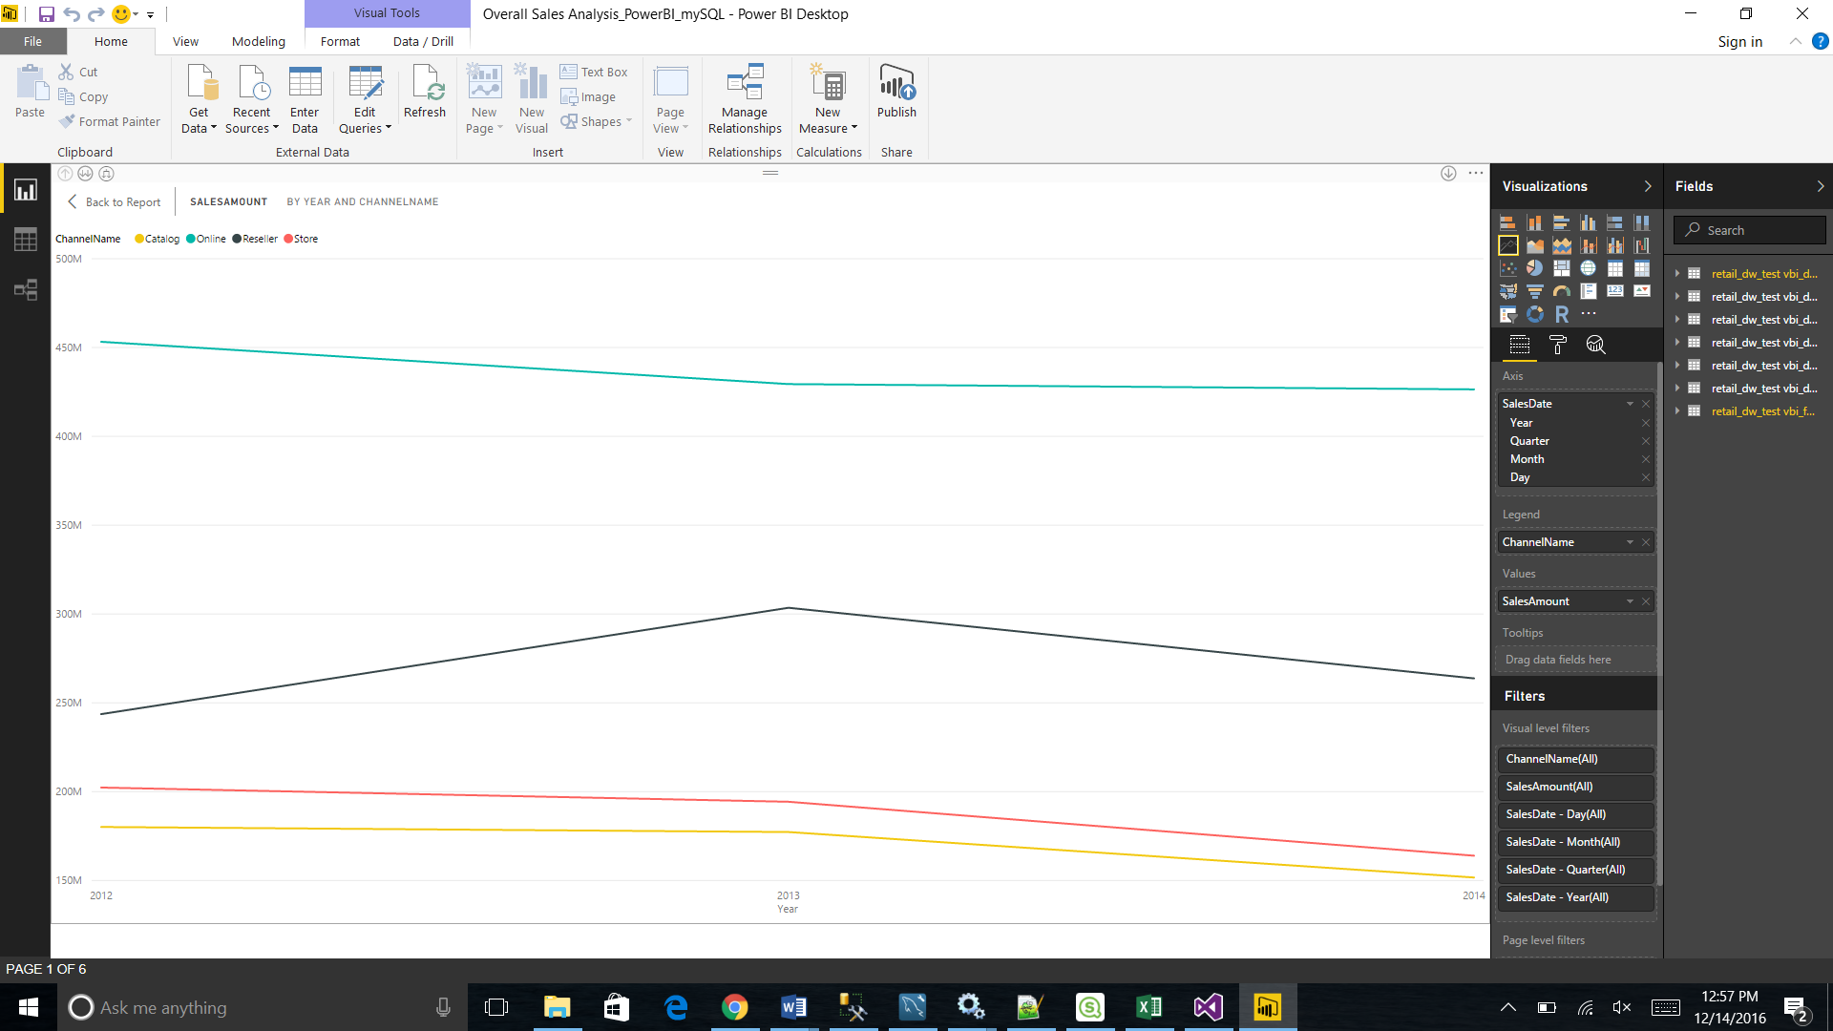
* As you can see from the above screens, the same analysis was performed both in tableau and powerBI and powerBI couldn’t generate a forecasting when multiple lines analysis was considered, it was able to forecast when we did for one line analysis.
* Loading FactsalesQuota, Fact StrategyPlan, factsales and scenario couldn’t be done on tableau, as they were returning a lot of rows, the minute we loaded data it only displayed a dialogue box saying query executing and it went on for 2 hours 10 mins and still nothing happened. Where as in PowerBI, the data got loaded in less than a minute, thought PowerBI has its issues when compared to Tableau, it turned out to be a very powerful tool.
* QlikSense tool was not straight forward tool as the rest three tools. Right from loading data, to creating filters and applying them it has a complete different approach which will take some time for someone who is used to tableau and powerBI
* As learned from the Business Intelligence and Data Silos chapters in the reading book, we could make out that Excel PowerPivot is majorly used by business power users, it may not have been that powerful or effective as the rest of the tools, but is easily understandable. There were scenarios where we had to use pie charts even though we know its not a good practice because power pivot didn’t leave us any opportunity other than using pie charts.
* Compared to others, Talend provides recommendations to us select the type of analysis.
* PowerPivot at times becomes difficult to put in an analysis chart as it doesn’t let us take what we want, but only allows us to take what it recommends, so we r forced to use the charts.
* PowerPivot, for creating measures and any calculated fields one should be familiar with the Excel formulas, it may be difficult if one doesn’t know them.
* PowerBI and Qliksense shows you a EER model in the tool once you load the tables, where by placing the curser on the relationship we can find out by what keys the tables are connected.